**Lab 01 Introduction to Python**

**Lab Activities:**

##### **Activity 1:**

Display numbers on screen using Python IDLE.

##### Solution:

##### 

##### **Activity 2:**

Display strings on screen.

##### Solution:

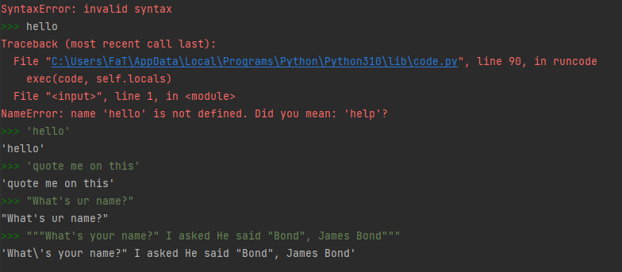

##### **Activity 3:**

Use Python as a calculator.

##### Solution:

##### 

##### **Activity 4:**

Get an integer answer from division operation. Also get remainder of a division operation in the output.

##### Solution:

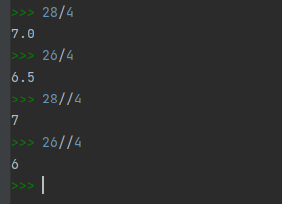

##### **Activity 5:**

Calculate 43, 410, 429, 4150, 41000

##### Solution:

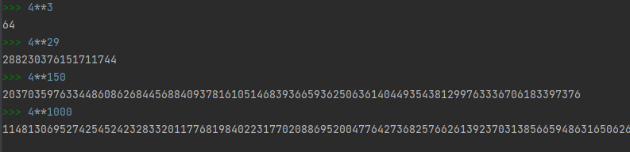

##### **Activity 6:**

Write following math expressions. Solve them by hand using operators’ precedence. Calculate their answers using Python. Match the results.

##### Solution:

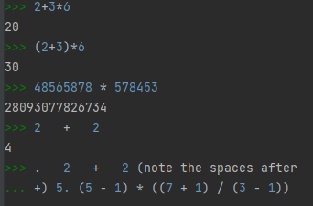

##### **Activity 7:**

Combine numbers and text.

##### Solution:

##### **Command**

# Text  
x = "Nancy"  
print(x)  
# Combine numbers and text  
s = "My lucky number is %d, what is yours?" %7  
print(s)  
# alternative method of combining numbers and text  
s = "My lucky number is " + str(7) + ", what is yours?"  
print(s)

##### **Output:**

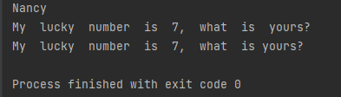

##### **Activity 8:**

Take input from the keyboard and use it in your program.

##### Solution:

##### **Command**

#!/usr/bin/env python3  
name = input('What is your name? ')  
print('Hello ' + name)  
job = input('What is your job? ')  
print('Your job is ' + job)

##### **Output:**

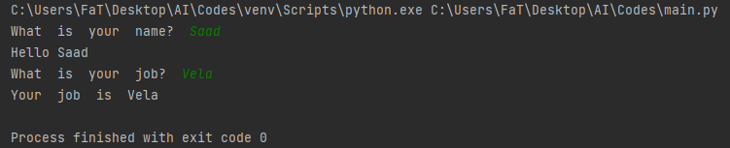

##### **Activity 9:**

Let us take an integer from user as input and check whether the given value is even or not.

Solution:

##### **Command**

n=input("Enter a number = ")  
if int(n)%2==0:  
 print("The given Number is even")

##### **Output:**

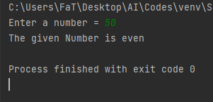

#### Activity 10:

Let us modify the code to take an integer from user as input and check whether the given value is even or odd. If the given value is not even then it means that it will be odd. So here we need to use if-else statement an demonstrated below.

*Solution:*

##### **Command**

n=input("Enter a number = ")  
if int(n)%2==0:  
 print("The given Number is even")  
else:  
 print("The given Number is odd")

##### **Output:**

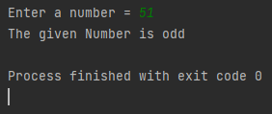

#### Activity 11:

Calculate the sum of all the values between 0-10 using while loop.

Solution:

##### **Command**

summation=0  
i=1  
while i<=10:  
 summation=summation+1  
 i=i+1  
print("The sum is = ", summation)

##### **Output:**

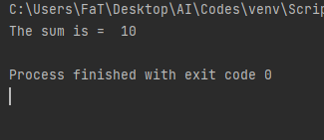

#### Activity 12:

Accept 5 integer values from user and display their sum. Draw flowchart before coding in python.

*Solution:*

##### **Command**

i=0  
while i<=4:  
 s=input("Enter Number: ")  
 n=int(s)  
 summ=summ+n  
 i=i+1  
  
print("Summ is = ", summ)

##### **Output:**

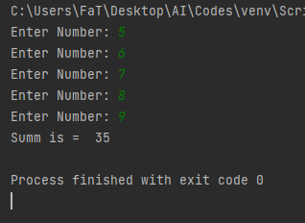

#### Activity 13:

Write a Python code to keep accepting integer values from user until 0 is entered. Display sum of the given values.

*Solution:*

##### **Command**

sum=0  
s=input("Enter an integer value : ")  
n=int(s)  
while n!=0:  
 sum=sum+n  
 s=input("Enter an integer value : ")  
 n=int(s)  
print("The sum of given values is = ", sum)

##### **Output:**

##### 

#### Activity 14:

Write a Python code to accept an integer value from user and check that whether the given value is prime number or not.

*Solution:*

##### **Command**

isp=True  
i=2  
n=int(input("Enter a Number "))  
while i<n:  
 rem=n%i  
 if rem==0:  
 isp=False  
 break  
 else:  
 i=i+1  
if isp:  
 print("Number is Prime")  
else:  
 print("Number is not Prime")

##### **Output:**

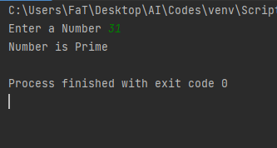

**Home Activities:**

*Activity 1:*

Write a Python code to accept marks of a student from 1-100 and display the grade according to the following formula.

Grade F if marks are less than 50 Grade E if marks are between 50 to 60 Grade D if marks are between 61 to 70 Grade C if marks are between 71 to 80 Grade B if marks are between 81 to 90

Grade A if marks are between 91 to 100

##### **Code:**

s=1  
while s<=100:  
 abc="Enter Marks Obtained for Student %d" %s  
 avg=int(input("Marks: "))  
 s=s+1  
 if avg>=91 and avg<=100:  
 print("Your Grade is A")  
 elif avg>=81 and avg<91:  
 print("Your Grade is B")  
 elif avg>=71 and avg<81:  
 print("Your Grade is C")  
 elif avg>=61 and avg<71:  
 print("Your Grade is D")  
 elif avg>=50 and avg<61:  
 print("Your Grade is E")  
 elif avg<50:  
 print("Your Grade is F")  
 else:  
 print("Invalid Input!")

##### **Output:**

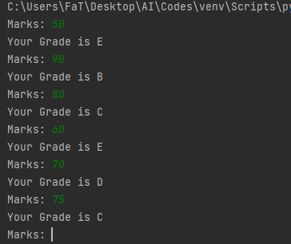

*Activity 2:*

Write a program that takes a number from user and calculate the factorial of that number.

##### **Code:**

num=int(input("Enter a number to calculate the factorial of: "))  
factorial = 1  
if num < 0:  
 print("Sorry, factorial does not exist for negative numbers")  
elif num == 0:  
 print("The factorial of Ois 1")  
else:  
 for i in range(1, num + 1):  
 factorial = factorial*i  
 print("The factorial of", num, "is", factorial),

##### **Output:**

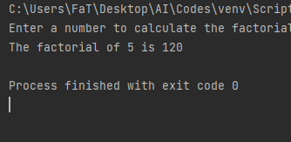

**Assignment:**

Fibonacci series is that when you add the previous two numbers the next number is formed. You have to start from 0 and 1.

E.g. 0+1=1 → 1+1=2 → 1+2=3 → 2+3=5 → 3+5=8 → 5+8=13

So the series becomes

0 1 1 2 3 5 8 13 21 34 55 ……………………………………

Steps: You have to take an input number that shows how many terms to be displayed. Then use loops for displaying the Fibonacci series up to that term e.g. input no is =6 the output should be

0 1 1 2 3 5

##### **Code:**

nterms = int(input("How many terms? "))  
n1, n2 = 0, 1  
count = 0  
if nterms <= 0:  
 print("Please enter a positive integer")  
elif nterms == 1:  
 print("Fibonacci sequence upto",nterms,":")  
 print(n1)  
else:  
 print("Fibonacci sequence:")  
 while nterms > count:  
 print(n1)  
 nth = n1 + n2  
 n1 = n2  
 n2 = nth  
 count += 1

##### **Output:**

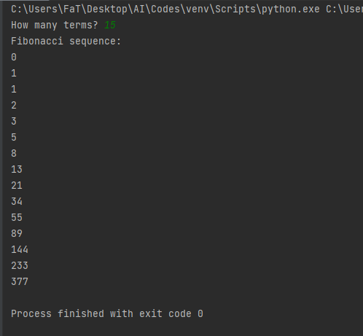

|  |
| --- |
| **Critical Analysis and Conclusion:**  In this lab we were introduced to Python Language. We also learnt basic programming commands i.e arithmetic, print scan, loops etc.  Python is a popular programming language. It was created by Guido van Rossum, and released in 1991.  It is used for:   * web development (server-side), * software development, * mathematics, * system scripting.  **What can Python do?**  * Python can be used on a server to create web applications. * Python can be used alongside software to create workflows. * Python can connect to database systems. It can also read and modify files. * Python can be used to handle big data and perform complex mathematics. * Python can be used for rapid prototyping, or for production-ready software development.  **Why Python?**  * Python works on different platforms (Windows, Mac, Linux, Raspberry Pi, etc). * Python has a simple syntax similar to the English language. * Python has syntax that allows developers to write programs with fewer lines than some other programming languages. * Python runs on an interpreter system, meaning that code can be executed as soon as it is written. This means that prototyping can be very quick. * Python can be treated in a procedural way, an object-oriented way or a functional way. |